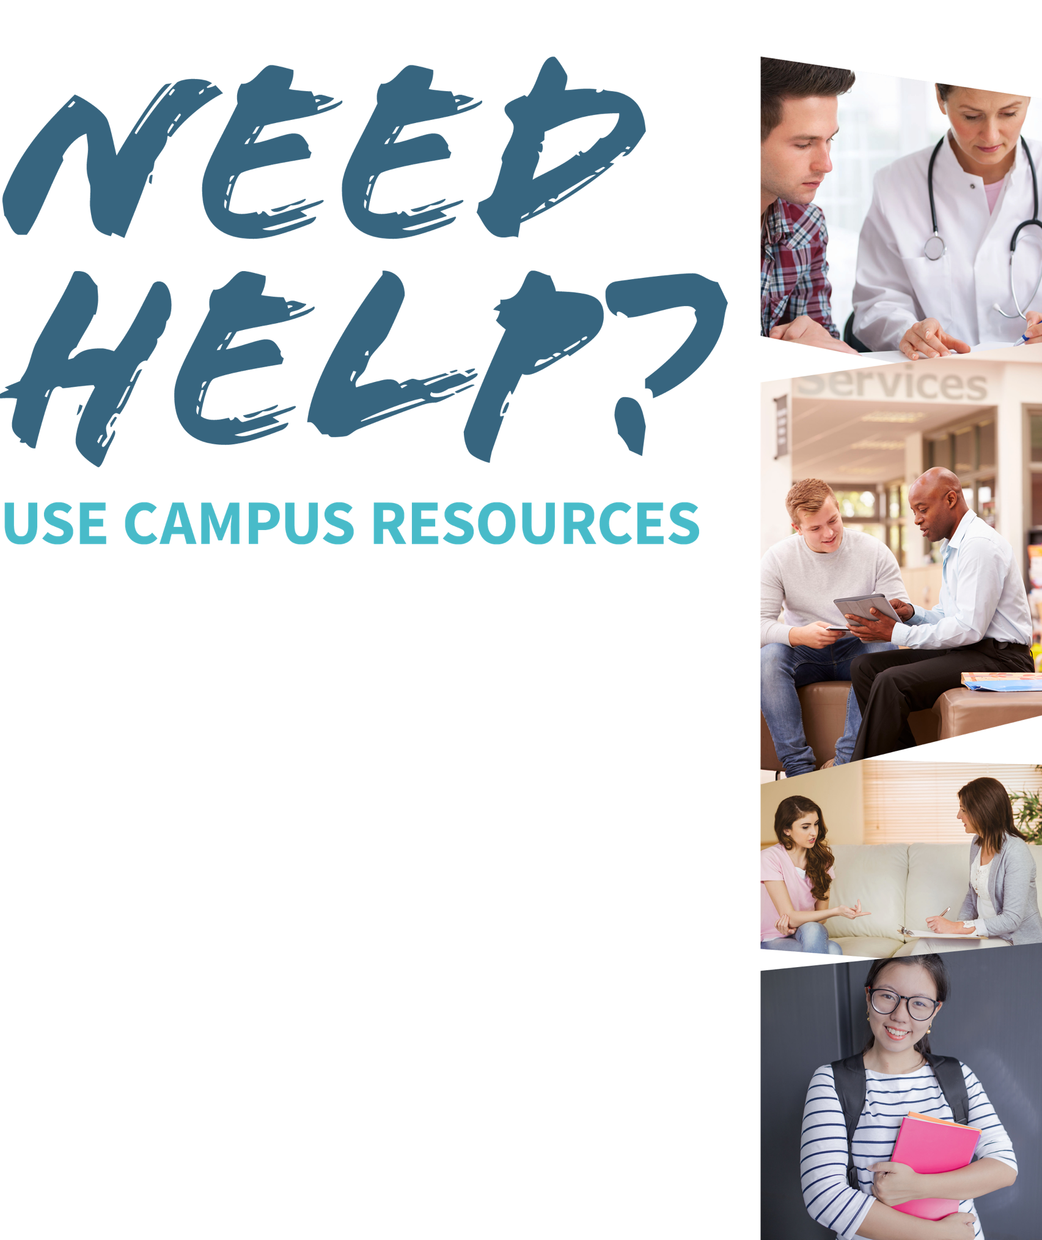
Student Health or Wellness Centers
Name and location

Campus Recovery Programs
Name and location

College or University Counseling Services Name and location

Academic Advising
Name and location

